**Name: Maryam Mehreen**

**Sap Id: 35889**

**Subject: Computer Networks**

**Lab 2**

Q1:Write down the advantages and disadvantages of RJ45 connectors?

**Advantages:**

* **Commonly Used:** RJ45 connectors are very common, so they work with many different devices and cables, making it easy to set up networks.
* **Simple to Use**: They are easy to attach to cables if you have the right tools, so almost anyone can do it.
* **Good for Fast Internet**: RJ45 connectors are great for fast internet connections, including both regular and high-speed networks.
* **Affordable**: RJ45 connectors are inexpensive and easy to find, making them a budget-friendly option for building networks.

**Disadvantages:**

* **Limited Range:** RJ45 connectors work best within a short distance (up to 100 meters), so they aren't great for long-distance connections without extra equipment.
* **Can Pick Up Interference**: If the cable isn't shielded, these connectors can be affected by electrical noise, which might slow down your connection.
* **Can Pick Up Interference**: If the cable isn't shielded, these connectors can be affected by electrical noise, which might slow down your connection.
* **Needs Careful Installation**: If the wires inside aren't connected properly, it can cause network problems, so installation needs to be done carefully.

Q2: **Briefly explain how the data is transmitted in wireless medium?**

In a wireless medium, data is sent through the air using radio waves, similar to how your phone receives signals.

1. **Data to Signal**: First, the data (like a webpage or a video) is turned into a signal that can travel wirelessly.
2. **Sending the Signal**: This signal is then sent out by a device like a Wi-Fi router, which broadcasts it through the air.
3. **Traveling**: The signal moves through the air in all directions, passing through walls and objects until it reaches the receiving device.
4. **Catching the Signal**: Your device, like a smartphone or laptop, catches the signal with its built-in receiver.

**Q3: Briefly explain all type of network topologies.?**

There are 5 types of Topologies

* Bus Topology
* Star Topology
* Ring Topology
* Mesh Topology
* Tree Topology

**Bus Topology**

* **Definition**: All devices are connected to a single central cable, called the bus.
* **Advantages**: Simple and cost-effective; easy to add new devices.
* **Disadvantages**: If the central cable fails, the entire network goes down.

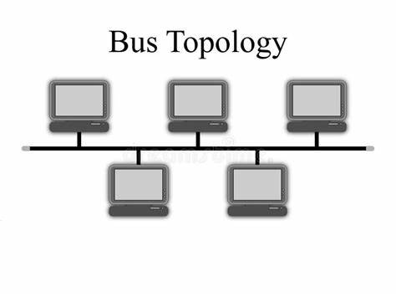

**2. Star Topology**

* **Definition**: All devices are connected to a central hub or switch.
* **Advantages**: Easy to manage and expand; if one device fails, the rest of the network remains unaffected.
* **Disadvantages**: If the central hub or switch fails, the entire network is affected; more cable is required compared to bus topology.

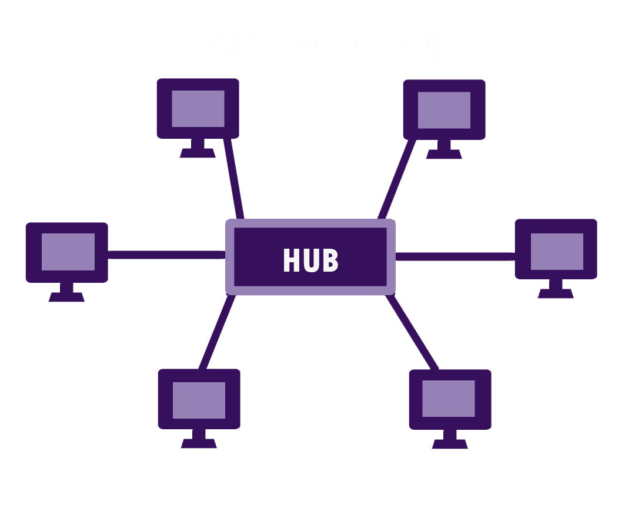

**3. Ring Topology**

* **Definition**: Devices are connected in a circular fashion, with each device connected to two others, forming a ring.
* **Advantages**: Data travels in one direction, reducing the chance of packet collisions; easy to identify where a fault occurs.
* **Disadvantages**: If one device or connection fails, it can disrupt the entire network unless there is a backup ring (dual ring).

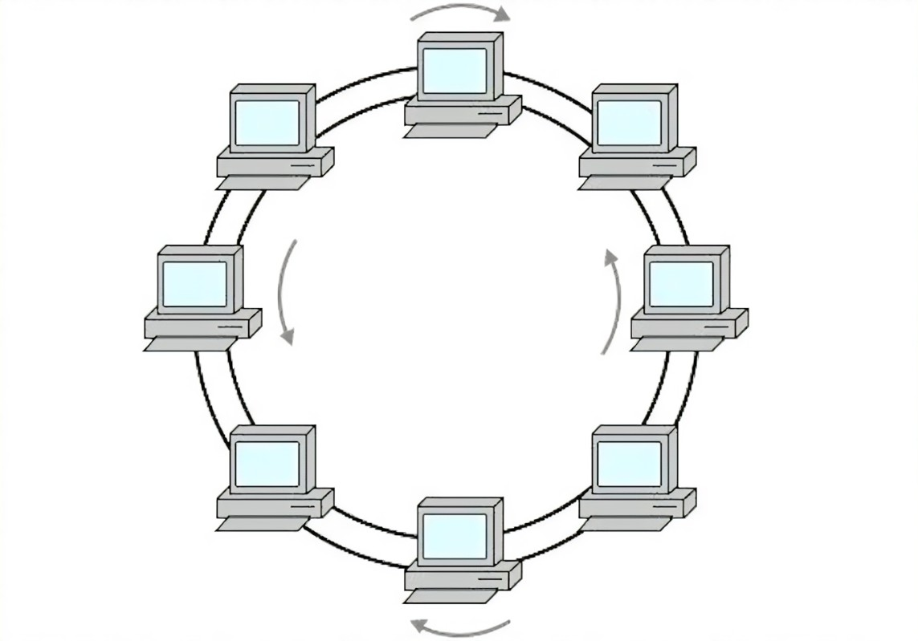

**4. Mesh Topology**

* **Definition**: Every device is connected to every other device in the network.
* **Advantages**: Very reliable because multiple connections provide redundancy; if one connection fails, data can take another path.
* **Disadvantages**: Expensive and complex to install and maintain due to the large number of cables and connections.

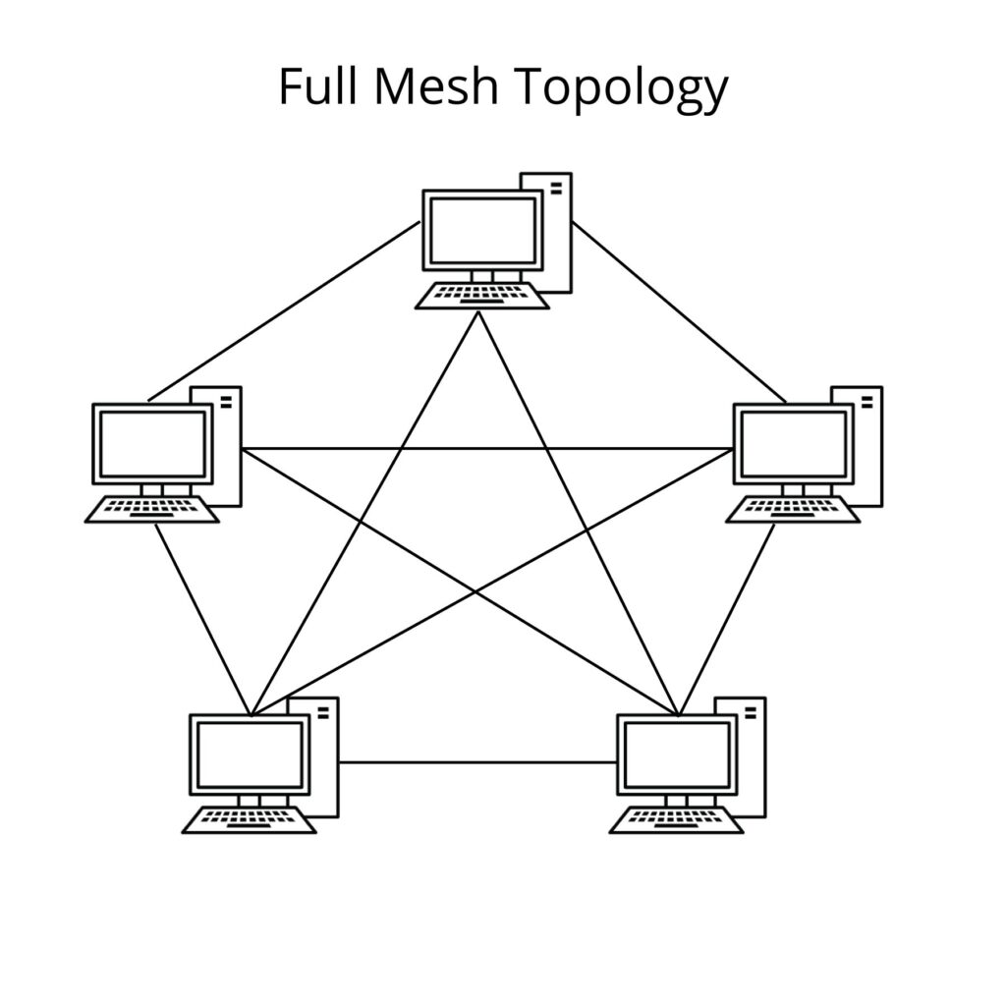

**5. Tree Topology**

* **Definition**: A combination of star and bus topologies, with groups of star-configured devices connected to a central bus.
* **Advantages**: Scalable and easy to expand; central hub controls data flow, making it easier to manage.
* **Disadvantages**: If the central bus fails, the entire network can be affected; more cabling required than bus topology.

